Zoobe Project Manager Documentation

- Disclaimer:
There are a couple of hard coded lines that would need to be changed into globalized variables or dynamic loads. As of 21/10/2013 these lines are enumerated and explained below:
  - Global Variables and Paths:
    - Line 34 = Temporary LOCATION of the project manager python file
    - Line 35 = Temporary PATH to the projects definition XML file
    - Line 36 = Temporary NAME of the projects definition XML File
    - Line867 and 1377 = Header Icon
    - Line 897,1012, 1144 and 1407, 1528, 1660 = Preview Default Icon
  - Missing structures:
    - Delete functionalities of the Asset Types, Assets, and Components Scroll Lists
    - Open File commands including the incremental save workshop, the save master, revive, and close procedures
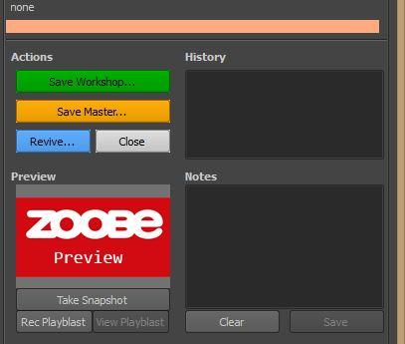
    - Saving of Component Data and Notes. Reading of said data for display purposes.
    - Display of selected component path and ability to explore or open an explorer window at displayed location.
    - Proper creation of new projects and display of project data for project managers in the project settings window.
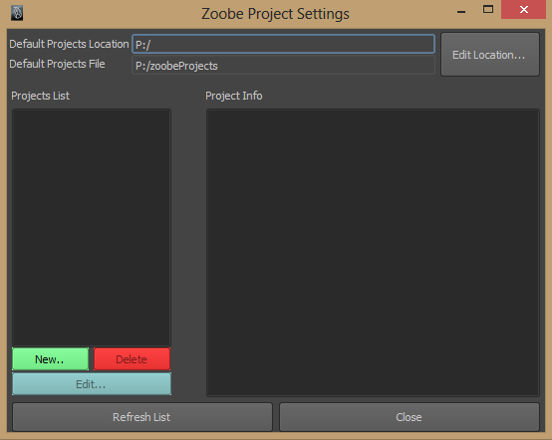
- Tool Summary:
Zoobe Project Manager is a python and MEL written asset management tool. It assesses and provides a solution to Zoobe's internal and external Maya projects. It's aim is to create a unitized system that could be incorporated across all content creation procedures.

- Key Features:
  - Manages Maya project creation, structure
  - Manages file naming
  - Manages file referencing
  - Manages file saving procedures
  - Provides a unified tool for all Zoobe related scripts

- Tool Documentation:
  - Menu Bar – Holds various menu commands related to the project manager or internal maya tools
    - File
      - Save Workshop... - Allows to save a Workshop file of the currently open asset. Workshop files are automatically named and a comment may be provided by the creator.
      - Save Master... - Allows to save a Master file, importing all referenced assets and supplanting any pre-existing workshop files. Naming is also handled by the Project Manager and allows a comment to be typed by the creator
    - Edit
      - Revive File... - Returns a file to a previously saved state. Returned state based on saved Workshop files.
    - Maya Tools – Holds various commonly used maya internal tools
      - Reference Editor... - Opens the Maya Reference Editor
      - Project Window... - Opens the Zoobe Project Settings window if the user name is part of the master users list
      - Set Project... - Opens up a directory browser to change/specify a new project destination. The set project gets over-ridden by the project selection drop down menu.
      - Namespace Editor... - Opens up the Maya Namespace Editor window
      - Hypershade – Opens up the Maya Hypershade window
      - Outliner – Opens a free standing Maya Outliner window if it is not already opened
      - Normals Toggle – Toggles the face normals visibility of selected polygonal objects
    - Add-Ons
      - Animation Binder... - Opens up the Zoobe Animation Binder window. This UI is used to bind the characterized fbx/mocap rigs, to the control rig. This is a necessary step, required to be able to bake the animation of fbx/mocap rigs to the controls of our characters. The Animation Binder script was originally developed and maintained by Oleg Solovjov.
    - Preferences
      - High Quality Playblast – Enables customized playblast settings where the playblast generated is of a higher quality. The settings for this playblast are written into the script itself and no user input is required.
    - Help
      - Documentation... - Opens up a Documentation page for the Zoobe Project Manager Tool
      - About Zoobe... - Opens up a brief description of the company Zoobe, and provides the URL for the company as well.
      - About Zoobe Project Manager... - Opens up a brief summary of the Zoobe Project Manager Tools
  - Header Controls:
    - User Name – Lists the current user name, derived from the user system variable
    - Project Name – Lists and displays the currently selected project, based on the projects found in the projects xml file
    - Project Path – Displays the path for the currently selected project. This is based on the project name control and the data in the projects xml file
    - Project Manager... - Opens up the Zoobe Project Settings UI, which allows a master user to create, edit, delete, and otherwise manage existing, past, or new projects
      - Zoobe Project Settings
        - Default Projects Location – Displays the default parent directory to all of Zoobe projects. This is an internal location, and may be edited if necessary
        - Default Projects File – Displays the default location of the xml file that holds all the existing projects data
        - Edit Location... - Allows the editing of the previously mentioned default locations
        - Projects List – Displays a list of all the projects found in the xml file
          - New... - Creates a new project and appends its data to the existing xml file
          - Delete – Deletes an existing project from the list and removes its data from the xml file. The binary files and assets already created for said project will remain in its current location but will not be managed anymore by this tool
        - Project Info – Displays information about the currently selected project. The data displayed is based on the data within the xml file
        - Refresh List – Tells the UI to look in the projects xml file location, locate the file, read through it and display all the projects found in it in the projects list
        - Close – Closes the Zoobe Project Settings UI
  - Currently Open
    - Actions
      - Save Workshop...
      - Save Master...
      - Revive...
      - Close
    - History
    - Preview
      - Rec Playblast
      - View Playblast
    - Notes
      - Clear
      - Save
  - Asset Browser
    - Asset Types – The Asset Types scroll list is populated upon script initialization and project selection switch. The contents of this list are derrived from the existing folders in the projects main folder. The main folder path is set through the script with the following parameters (projects_path\project_name\working_project\)
      - New... - Creates a new folder under the previously mentioned path
      - Delete - Deletes the folder and all the children contents of the currently selected Asset Types scroll list member
    - Assets – The Assets scroll list is populated based on the selection and contents of the Asset Types list's currently selected member.
      - Actions...
      - New... - Creates a new folder under the Assets Types list currently selected item, and includes it in the Assets sroll list as a new member
      - Delete - Deletes the folder and all the children contents of the currently selected Asset scroll list member
    - Components - Lists the children accepted file types found within the currently selected Asset scroll list member. Accepted file types include: '.mb' and '.ma' files. The following files amy also be included if desired: '.fbx'and '.obj'
      - Actions...
      - New... - This button is only available to Master Name users. The “New...” button allows for the creation and assignment of new workshop files within the currently selected Assets scroll list children directory. The name assigned upon creation will be used for the consecutive incremental save of Workshop files. The new file created may be an empty scene, or an export of the currently open scene. The new item will be included in the current Components scroll list at the bottom of the list. The order may change in a future Zoobe Project Manager initialization due to system alphabetical organization.
      - Delete - This button is only available to Master Name users. The “Delete” button allows for the deletion and deletion of the currently selected Components member.
    - Preview - Shows a thumbnail of the contents of the currently selected Components scroll list member
      - View Playblast - If the selected component has a playblast file created for it, the playblast may be opened using the system's default video player.
    - History - Displays text based on XML data saved with the currently selected Component scroll list member. The data displayed includes: last date the file was worked on, which user worked on it, the time it was submitted, any comments the user might have included, the latest version of the file based on the incremental save data
    - Notes - Displays text notes that may have been written while working on the file. These notes are indepented of the file comments which are permanent. File notes may be cleared, these are included to provide notes for future users working on the same file.
  - Shot Browser
    - Sequence
      - New...
      - Delete
    - Shot
      - New...
      - Delete
    - Components
      - New...
      - Delete
    - Preview
    - History
    - Notes
  - Footer Controls
    - Location Controls
      - Path Field
      - Explore
    - Refresh UI
    - Close UI

